ASSESSMENT FOR ORGANISATIONS

REFLECTION

ETHICAL SHORT-TERM MISSIONS & VOLUNTEERING
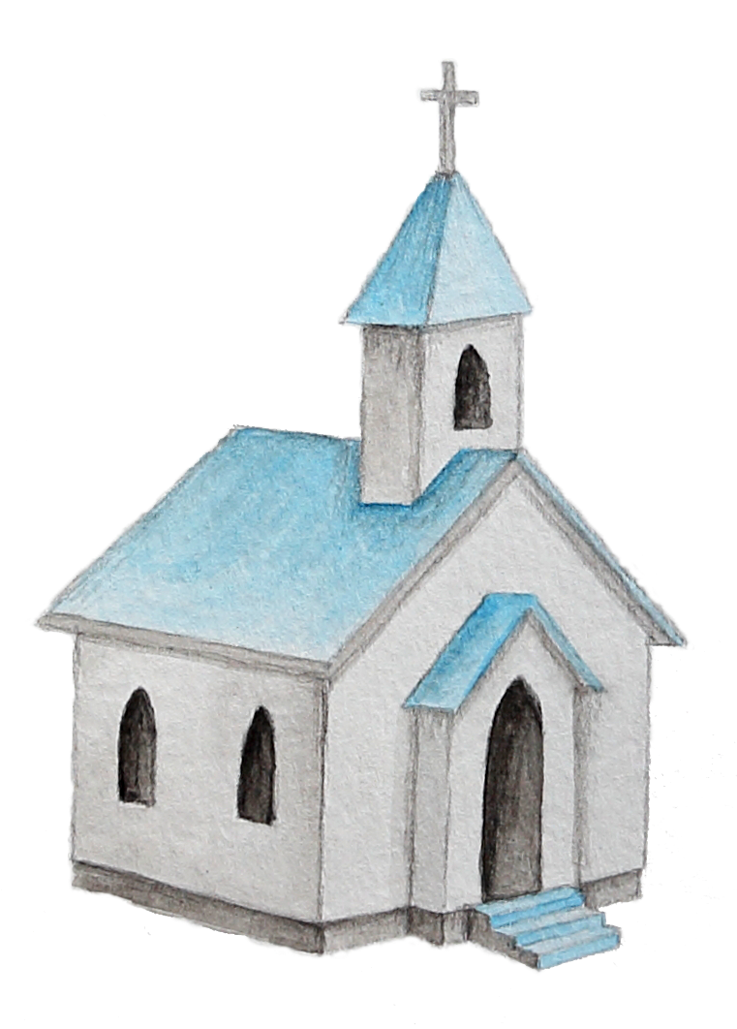
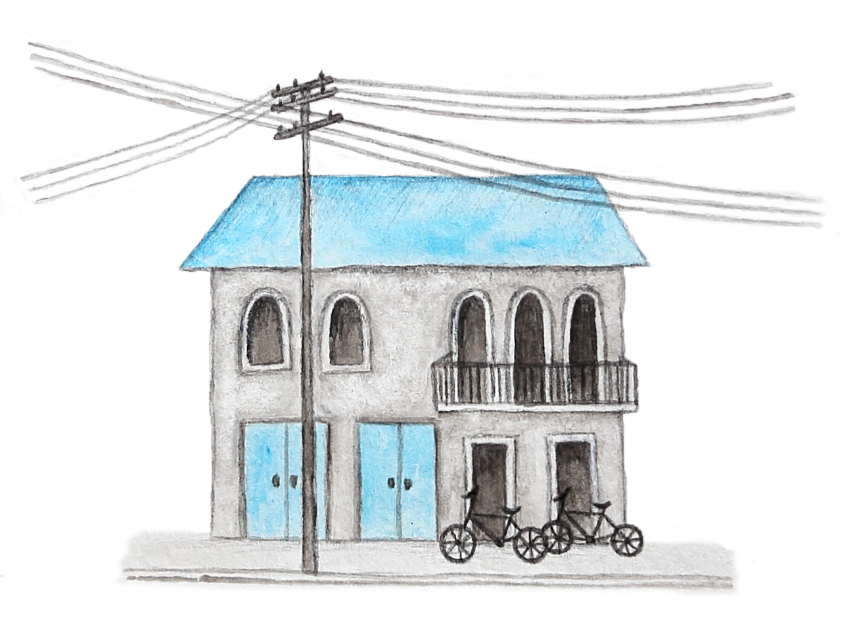

ethicalmissionstrips.org

INTRODUCTION

The following tool has been designed to guide you as you reflect on the information contained in the ethical framework in the context of your organisation’s STM or volunteer program or trips.
Note:
Before beginning this self-assessment. make sure you have read about the ethical framework at ethicalmissionstrips.org

THIS TOOL IS FOR FACILITATING ORGANISATIONS INCLUDING:
Receiving Organisations
Sending Organisations
Any on-field persons or organisations who receive teams and facilitate volunteers whilst in the host country or community.
Organisations that mobilise & prepare teams/volunteers to go into a host country or community.
e.g. Host churches, schools, community groups, non-government organisations, tour companies etc.
e.g. Churches, travel companies, charities, mission agencies, schools, universities, or volunteer agencies etc.

Note: If you are a volunteer or prospective team member download the individual reflection tool found at- ethicalmissionstrips.org/reflect-apply

WHAT NEXT:

Once you've completed the reflection, you'll be well positioned to move through the implementation stages involved in evaluating or developing your organisation’s STM or volunteer program.

Information about the steps involved developing an ethical trip can be found at: ethicalmissionstrips.org/org-intro

“‘Desire without knowledge is not good, and whoever makes haste with his feet misses his way’.
— Proverbs 19:2 (ESV)

STEP 1: IDENTIFY YOUR MOTIVATIONS, GUIDING PRINCIPLES, GOALS & METHODS?
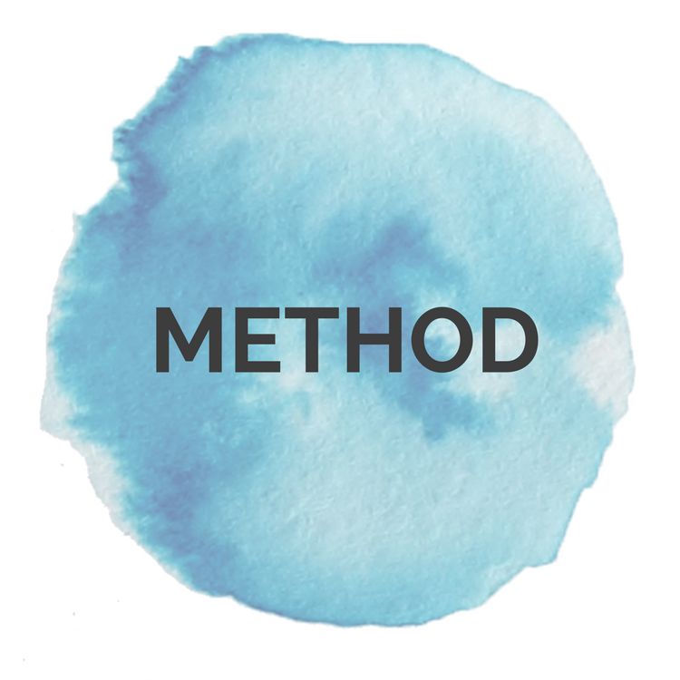

Think about your organisation’s current motivations, guiding principles, goals and methods with respect to STM trips. Write your thoughts down in the table below.
Tip: If you get stuck, refer to the website for details about each of these key considerations.

Note: Start by writing a first draft. After completing the ‘Step 2: Checklist’ you’ll have an opportunity to evaluate and revise your answers.

QUESTION: | YOUR RESPONSE:
- MOTIVATIONS:
What motivates us to organise STM trips?

- GUIDING PRINCIPLES:
What guiding principles inform our approach to STM trips?

- Which Biblical principles?
- What sector specific good practice principles (e.g. medical, education, child development)?

- GOALS:
What are the goals of the STM trips?

- METHOD:
How do we achieve the above stated goal?
- What types of trips do you organize
e.g. learning, doing, exposure trips
- What types of activities do teams get involved in?
i.e. specific trip activities

STEP 2: COMPLETE CHECKLIST
Let’s Be Honest:
Some of the questions below are direct and may be challenging to answer.
However, asking ourselves these tough questions can help us to dig deeper and really refine our STM programs.

With step one completed, it’s time to use the below checklist to identify any areas of concern. This gives you an opportunity to raise and address any high-risk areas.

 | TEAM SKILLS & EXPERIENCE | Yes | No | Unsure
 | Do we require team members to have qualifications and experience appropriate to the trip activities?  i.e. what would be required of team members in their own countries |  |  |  | It is never wise for teams to take on tasks which they are unqualified for and lack experience to do. This can lead to wasted resource, duplication, poor outcomes, accidents and hazards. When working with children, it can lead to harm and can undermine children’s development. Parents and community members are likely to assume teams are qualified, therefore we need to be very responsible with their trust.  It’s also important to realise that whilst team members might be trained and have experience, the context may be very different and the cultural and language barriers will make it challenging for them to transfer their skills. It is wise to think through how you will overcome context related challenges to maximise impact.
Are we engaging teams in:
- Learning & exposure?
 | - Skills exchange?
 | - Capacity building of local people?
 | - Direct tasks that results in teams replacing local staff or duty bearers or taking away local jobs? |  |  |  | Doing something for a community that they are already capable of doing themselves can be disempowering. It can subtly reinforce inferiority and discourage community-led action. Consider doing something ‘with’ rather than ‘for’ the community. Where possible encourage local initiatives and where extra hands and manpower is helpful, work alongside the community. This fosters relationship and communicates that you respect, recognise and value the skills local people already possess.  For every human right, there is someone responsible for making sure people can achieve their rights. These people are called duty bearers. A person is a duty bearer on the basis of their role/occupation, i.e. parents for children’s care, teachers for student’s education. The best way for teams to support people to access their rights is by supporting duty bearers to fulfil their roles. When teams take over the roles of duty bearers it can be detrimental in the long-term. They can cause disruption, inconsistency, and undermine the social systems that children and communities depend on. For more info see: ethicalmissionstrips.org/principles/
 | VULNERABLE GROUPS: | Yes | No | Unsure
- . | Do teams engage with any of the following vulnerable people groups:  - At risk children  i.e. orphaned/vulnerable children |  |  |  | As Christians, we naturally want to help people who have suffered from abuse, exploitation, violence, or extreme poverty and social exclusion. However, visiting or volunteering in programs providing vulnerable populations with support or rehabilitation is seldom the right way to do it.  When lots of teams visit people on the basis of a trauma or vulnerability it can evoke and compound feelings of shame, reinforce stigmatizing labels, compromise privacy and confidentiality, undermine the effectiveness of therapeutic programs and in some instances, compromise client’s safety. Because of these risks it is rarely ethical.  To avoid this ask yourself “Is this contact about my empathy and curiosity or is it critical to the person/s rehabilitation and development?’.
 | - Survivors of trafficking
 | - Survivors of abuse
- People facing extreme forms of poverty
i.e. Communities living in slums or rubbish dumps
- Displaced people
i.e. Stateless people or refugees, people affected by disasters
 | HIGH RISK AREAS: | Yes | No | Unsure
 | Do we facilitate teams to participate in areas where there is a well-known and documented risk of harm:  - Visiting or volunteering with children in residential care?  i.e. This includes orphanages, children’s homes, children’s villages, shelters, rescue homes etc. |  |  |  | Remember good intentions don’t automatically result in good outcomes and therefore when volunteers engage in activities that are known to cause harm, either on an individual on a systems level, alternative methods need to be sought.  Volunteering and visiting children in residential care (e.g. orphanages) is one of these areas. For info unpacking the harmful effect of orphanage volunteering- ethicalmissionstrips.org/orphanagevolunteering/
 | - Participate in 'raids and rescues' for children or adults?  i.e. ‘rescuing’ of trafficked victims, child protection interventions, removing children from situations of abuse or placing children in residential care. |  |  |  | Teams should never get involved in legal and criminal matters or formal child protection interventions. This must be left to the relevant authorities and licensed organisations.  Teams should report all child protection concerns to the authorities or an in-country NGO who specializes in child protection.
 | - Engaging in humanitarian/disaster response work or working in a conflict zone. |  |  |  | Post disaster or humanitarian crisis situations are very complex and dangerous, and generally not suitable for unqualified STM teams.  There many examples, of well-intentioned teams volunteering in the aftermath of a disaster and causing more harm than good by duplicating services, taking over local led responses, bringing unusable goods into the country, using scarce resources, and responding inappropriately to the needs of orphaned and unaccompanied children. Teams should consider waiting and supporting the long-term rebuilding efforts after the initial response has passed.  Volunteering in post disaster/emergency context should be reserved for specialized volunteers being deployed by disaster response agencies.
 | - Providing medical care |  |  |  | Medical STM is a high-risk area.  Even for qualified doctors, there are risks to providing medical or dental treatment to people overseas without knowledge of patient’s medical histories.  Consideration should be given to sustainability, particularly in the case of pop up medical clinics.  Surgeons and specialists should volunteer through formal hospital skills exchange and volunteer programs to maximize impact and ensure proper after care and follow up arrangements are in place.  Doctors may need to apply for local licenses or special government permission to practice in a foreign country, so make sure you look into this well in advance and acquire all appropriate licenses.  There have been prosecutions against doctors on STM trips practicing without license and in cases where death or disability has ensued.
 | MOTIVATIONS & EXPECTATIONS
- . | For sending organisations:  Would we proceed with the STM trip if:  - teams were asked to take on support roles (such as admin or office tasks)) instead of working directly with local people or children?  - the team’s ideal itinerary couldn’t be accommodated and alternatives that better served the community were offered?  - There are restrictions imposed on capturing images, video and social media? |  |  |  | Questions like these help us to honestly asses our motivations for participating in STM trip. Where more than one motivation exists, it helps us work out which one is a stronger motivation.  For more info refer to: https://ethicalmissionstrips.org/motivations/.
For receiving organisations:
Are you willing to:
- put appropriate boundaries in place regarding team’s interaction with beneficiaries and local communities even it if impacts fundraising?
- prioritise the goals, needs and safety of any vulnerable people you work with regardless of the reaction from your visiting teams and donors?
 | Would I still invest in sending or receiving teams knowing:  - that there are limits to the impacts that can be realistically achieved in a short-period of time?  - the greatest impact Is likely to result from what the team members learn through the experience? |  |  |  | Realistic expectations are critical to ethical STM. They are the first step in fostering mutually respectful relationships with local actors.  When we aren’t realistic about the impact STM teams can have in a short space of time, we are more likely to be focused on providing solutions and less likely to focus on listening and learning from local people. When we do this, we risk adopting a savior mentality and diminishing the efforts of local people and local organisations.  There is also a danger that organisations will create experiences to cater to these unrealistic expectations. However, these experiences can be smoke and mirrors or worse, can undermine local people’s initiatives.

ASSESSING THE CHECKLIST:

Go over the checklist and assess your answers using the key below. Take note of any areas which require further reflection, research or where certain activities should be reconsidered before continuing to plan STM trips.

- SAFE: Based on your answers there are no concerns.

- APPROACH WITH CAUTION: Carefully consider any areas where caution is advised and ask more questions of the facilitating organisation if necessary. See if there are simple adjustments that could be made to reduce any risks or enhance outcomes for local communities. Refer to the website or linked resources to assist you.

- WARNING: If you ticked any red boxes, then it is strongly advised that you reconsider the trip or any high-risk activities, due to the well documented risk of harm that could be caused to children or communities.

- UNSURE: Conduct further research so you can answer questions marked as unsure before continuing with your STM trips.

STEP 3: DETERMINE NEXT STEP

Has this process highlighted: | Yes
- no areas of concern or required changes to initial responses. |  | Reflection completed. Proceed with the trip plans.
- required changes to our initial stated motivations, guiding principles, goals and method stated in Step 1. |  | Go back to Step 1 and amend responses.
- areas where further research, reflection and prayer is required before our approach can be finalised. |  | Conduct required actions before returning to finalise responses in Step 1.
- concerns or red flag areas that need to be addressed. |  | Address the required areas before proceeding.

