SELF-ASSESSMENT FOR INDIVIDUALS

REFLECTION

ETHICAL SHORT-TERM MISSIONS & VOLUNTEERING
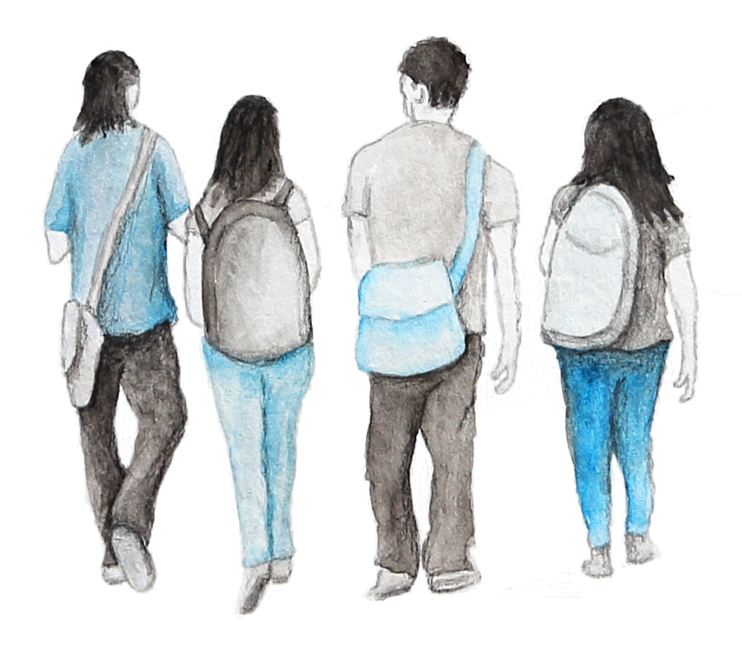

ethicalmissionstrips.org

INTRO
Note:
Before beginning this self-assessment. make sure you have read about the ethical framework at ethicalmissionstrips.org
The following tool has been designed to guide you as you reflect on the information contained in the ethical framework and consider how it applies to you as a STM team member or volunteer.

THIS TOOL IS FOR:

Individual Team Members & Volunteers
Note:
If you represent a STM facilitating organisation, download the organisation reflection tool found at- ethicalmissionstrip.org/reflect-apply

WHAT NEXT:

Once you've completed this reflection, you'll be well positioned to move through the process of selecting, preparing for and participating in an ethical STM trip.

Information about each of these steps, including a tool designed to help you select an ethical trip, can be found at: ethicalmissionstrips.org/ind-intro

“‘Desire without knowledge is not good, and whoever makes haste with his feet misses his way’.
— Proverbs 19:2 (ESV)

STEP 1: WHAT IS YOUR MOTIVATIONS, GUIDING PRINCIPLES, GOALS & METHOD?
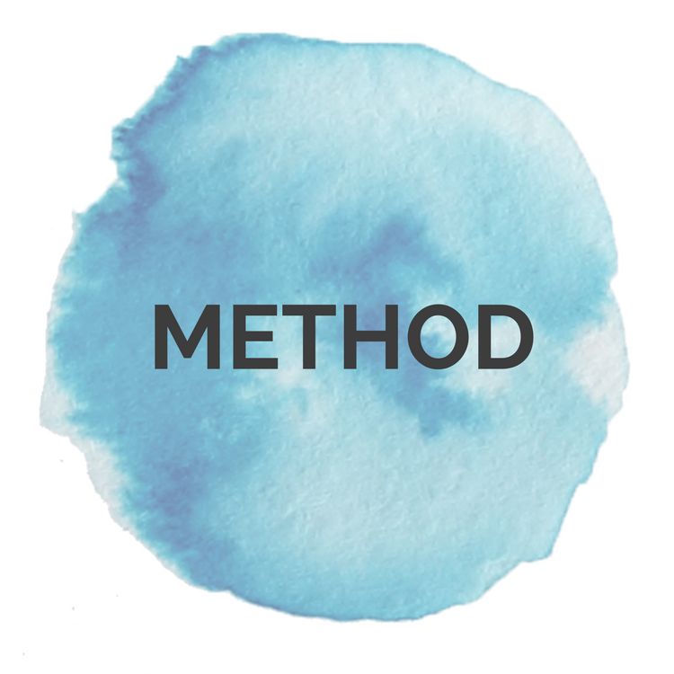
Tip: If you get stuck, refer to the website for details about each of these key considerations.
Think about your current motivations, guiding principles, goals and method regarding your planned involvement in STM. Write your thoughts down in the table below.

Note: Start by writing a first draft. After completing the ‘Step 2: Checklist’ you’ll have an opportunity to evaluate and revise your answers.

QUESTION: | YOUR RESPONSE:
- MOTIVATIONS:
What is motivating me to go on a STM trip?

- GUIDING PRINCIPLES:
What principles are guiding my decisions as I embark upon a STM trip?

- Which Biblical principles?
- What sector specific good practice principles (e.g. medical, education, child development)?

- GOALS:
What is the primary goal I want to see achieved through a STM trip?

- METHOD:  What approach am I considering taking to achieve my above goal?  - Tick what type of trip you are interested in going on:  - Provide any further details:  i.e. specific activities are on a trip | Action orientated trips  Skills Based Volunteers and Exchanges  Asset Based Community Development Trips  Learning Orientated trips  Exposure Trips  Advocacy Trips

STEP 2: COMPLETE CHECKLIST
Let’s Be Honest:
Some of the questions below may seem direct and may be challenging to answer.
However, asking ourselves these tough questions before we embark on a trip can help us to dig deeper and really refine our plans.

Now that you have identified your motivations, guiding principles, goals and methods, it’s time to use the below checklist to identify any red flags. This gives you an opportunity to address any high-risk areas before you select a trip.

 | SKILLS & EXPERIENCE: | Yes | No | Unsure
 | - With my current skills and qualifications, would I be permitted to undertake this role in my own context?  - If YES, is it appropriate given my level of local language skills, cultural knowledge, understanding of local systems, laws etc.? |  |  |  | It is never wise for teams to take on tasks which they are unqualified for and lack experience to do. This can lead to wasted resource, duplication, poor outcomes, accidents and hazards. When working with children, it can lead to harm and can undermine children’s development. Parents and community members are likely to assume teams are qualified, therefore we need to be very responsible with their trust.
 |  |  |  |  | It’s also important to realise that whilst team members might be trained and have experience, the context may be very different and the cultural and language barriers will make it challenging for them to transfer their skills. It is wise to think through how you will overcome context related challenges.
 | Would I be happy if someone (with my level of qualification, experience local language skills etc.) did the same thing in my community, school, church, workplace or with my children? |  |  |  | For example, would I be comfortable with my child (or a child I cared about):  - receiving medical treatment from a team of foreign doctors who have no knowledge of my child’s medical history?  - attending a school or day care that relies on untrained short-term volunteers from non-English speaking countries?  Even if the service is genuinely required, we need to consider alternative ways that don’t compromises the rights and long-term care of children or community’ members. For example, rather than providing direct treatment, medical teams could help build the capacity of local clinics so adults and children can access better medical care long-term.
 | Is the sector I am planning on volunteering in:  - a sector I have experience in?  - a sector where I am familiar with the sector specific good practice and guiding principles? |  |  |  | Sectors include education, healthcare, law, child protection, business, church planting/ministry, mental health, welfare etc.  Most sectors have good practice principles or codes of ethics in place that set the standards for professional practice and conduct as well as prevent harm.
 | Am I aiming to do something that the community are able to do for themselves? |  |  |  | Doing something for a community that they are already capable of doing themselves can be disempowering. It can subtly reinforce inferiority and discourage community-led action. Consider doing something ‘with’ rather than ‘for’ the community. Where possible encourage local initiatives and where extra hands and manpower is helpful, work alongside the community. This fosters relationship and communicates that you respect, recognise and value the skills local people already possess.
 | With respect to the goals and activities I am considering involvement in, who has the long-term responsibility (duty bearer)? | Duty bearer: |  |  | For every human right, there is someone responsible for making sure people can achieve their rights. These people are called duty bearers. A person is a duty bearer on the basis of their role/occupation, i.e. parents for children’s care, teachers for student’s education. The best way for teams to support people to access their rights is by supporting duty bearers to fulfil their roles. When teams take over the roles of duty bearers it can be detrimental in the long-term. They can cause disruption, inconsistency, and undermine the social systems that children and communities depend on.  For more info see: ethicalmissionstrips.org/principles/
Am I aiming to:
- build the capacity of the duty bearer so they can better fulfill their responsibility?
or
- participate in an activity which will temporary replace them in their role?

 | VULNERABLE GROUPS: | Yes | No | Unsure
6. | Am I considering engaging with any of the following vulnerable people groups:  - At risk children  i.e. orphaned or vulnerable children |  |  |  | As Christians, we naturally want to help people who have suffered from abuse, exploitation, violence, or extreme poverty and social exclusion. However, visiting or volunteering in programs providing vulnerable populations with support or rehabilitation is rarely the right way to do it.  When lots of teams visit people on the basis of a trauma or vulnerability it can evoke and compound feelings of shame, reinforce stigmatizing labels, compromise privacy and confidentiality, undermine the effectiveness of therapeutic programs and compromise client’s safety.  Because of these risks it is rarely ethical.  To avoid this ask yourself “Is this contact about my empathy and curiosity or is it critical to the person/s rehabilitation and development?’.
 | - Survivors of trafficking
 | - Survivors of abuse
- People facing extreme forms of poverty
- i.e. Communities living in slums, rubbish dumps
- Displaced people
- i.e. Stateless people or refugees, people affected by disasters
 | HIGH RISK AREAS: | Yes | No | Unsure
7. | Am I consider participating in an area where there is a well-known and documented risk of harm:  - Visiting or volunteering with children in residential care?  i.e. This includes orphanages, children’s homes, children’s villages, shelters, rescue homes |  |  |  | Remember good intentions don’t automatically result in good outcomes and therefore when volunteers engage in activities that are know to cause harm either on an individual on a system level alternative method needs to be sought.  Volunteering and visiting children in residential care (e.g. orphanages) is one of these areas. For info unpacking the harmful effect of orphanage volunteering- ethicalmissionstrips.org/orphanagevolunteering/
 | - Participate in 'raids and rescues' for children or adults?  i.e. ‘rescuing’ of trafficked victims, child protection interventions, removing children from situations of abuse or placing children in residential care. |  |  |  | Teams should never get involved in legal and criminal matters. This must be left to the relevant authorities and licensed organisations.  Teams should report all child protection concerns to the authorities or an in-country NGO who specializes in child protection.
 | - Engaging in humanitarian/disaster relief or working in a conflict zone. |  |  |  | Post disaster or humanitarian crisis situations are very complex and dangerous, and generally not suitable for unqualified STM teams.  There many examples, of well-intentioned teams volunteering in the aftermath of a disaster and causing more harm than good by duplicating services, taking over local led responses, bringing unusable goods into the country, using scarce resources, and responding inappropriately to the needs of orphaned and unaccompanied children. Teams should consider waiting and supporting the long-term rebuilding efforts after the initial response has passed.  Volunteering in post disaster/emergency context should be reserved for specialized volunteers being deployed by disaster response agencies.
 | - Providing medical care |  |  |  | Medical STM is a high-risk area.  Even for qualified doctors, there are risks to providing medical or dental treatment to people overseas without knowledge of patient’s medical histories.  Consideration should be given to sustainability, particularly in the case of pop up medical clinics.  Surgeons and specialists should volunteer through formal hospital skills exchange and volunteer programs to maximize impact and ensure proper after care and follow up arrangements are in place.  Doctors may need to apply for local licenses or special government permission to practice in a foreign country, so make sure you look into this well in advance and acquire all appropriate licenses.  There have been prosecutions against volunteer doctors on STM trips practicing without license and in cases where death or disability has ensued.
 | MOTIVATIONS & EXPECTATIONS: | Yes | No | Unsure
8. | Would I still be willing to go on the trip if:  - I’m required to take on a support role (e.g. admin) rather than work directly with communities or children?  - my goals and plans can’t be outworked however the trip will still benefit local people?  - If there was a ban on using social media during the trip? |  |  |  | Questions like these help us to honestly asses our motivations for participating in STM trip. Where more than one motivation exists, it helps us work out which one is a stronger motivation.  For more info refer to: https://ethicalmissionstrips.org/motivations/.
9. | Would I still invest in going on the trip knowing:  - the most significant impact of that there are limits on the impacts that can be realistically achieved in a short-period of time?  - the trip might be in my life not in the lives of the local people I meet? |  |  |  | Realistic expectations are critical to ethical STM. They are the first step in fostering mutually respectful relationships with local actors.  When we aren’t realistic about the impact we can have in a short space of time, we are more likely to be focused on providing solutions and less likely to focus on listening and learning from local people. When we do this we risk adopting a savior mentality and diminishing the efforts of local people and local organisations.  There is also a danger that organisations will create experiences to cater to these unrealistic expectations, however these experiences can be smoke and mirrors or worse, can undermine local people’s initiatives.

ASSESSING THE CHECKLIST:

Go over the checklist and assess your answers using the key below.

Take note of any areas which require further reflection, research or needs to be reconsiders before continuing to plan for your future involvement in STM.

- SAFE: Based on your answers there are no concerns.

- APPROACH WITH CAUTION: Carefully consider any areas where caution is advised and ask more questions of the facilitating organisation if necessary. See if there are simple adjustments that could be made to reduce any risks or enhance outcomes for local communities. Refer to the website or linked resources to assist you.

- WARNING: If you ticked any red boxes, then it is strongly advised that you reconsider taking part in the trip or any high-risk activities, due to the well documented risk of harm that could be caused to children or communities.

- UNSURE: Conduct any further research or thinking so you can answer questions marked as unsure before continuing with your planned involvement in STM.

STEP 3: DETERMINE NEXT STEPS

Has this process highlighted: | Yes
- required changes to my motivations, guiding principles, goals and method stated in Step 1? |  | Go to Step 1 and finalise responses.
- areas where further research, reflection and pray is required before continuing to explore joining a STM trip? |  | Conduct required actions before finalising responses in Step 1.
- concerns or red flag areas that need to be addressed? |  | Stop and address the required areas.
- that at this point of time an overseas trip is not the most effective way to achieve the goal and I could better serve the group/organisation through a different means? |  | Explore alternative means.
- no areas of concern or required changes to initial responses? |  | Begin planning to join a STM trip. See ethicalmissionstrips.org/ind-intro

